 | KiCAD PORTFOLIO  TRAVOLTA CHIPOSI-MUDIWA (he/him/his)  MSE, Mechanical Engineering | Johns Hopkins University | Baltimore MD, USA (May 2027)  B-Tech Honors, Electronic Engineering | Harare Institute of Technology | Harare, ZWE (Oct 2024)  410 814-1812 | tchipos1@jh.edu | LinkedIn | Github

CONTENTS
DESIGNS II
LI-PO_BATTERY_CHARGER (MCP73831) II
INTRODUCTION TO KICAD PROJECT IV

DESIGNS

LI-PO_BATTERY_CHARGER (MCP73831)
- x 1, Single-Cell Li-Ion/Li-Po Charge Management Controller, Part: MCP73831T-2ACI/OT or MCP73831
- J2: Battery Connector (JST-PH or 2-pin header), Part: Conn_01x02 or JST_PH
- C1, C2: Surface Mount Ceramic Capacitors, Part: C
- J1: Micro-USB Connector, Part: USB_B_Micro
- R1, R2: Surface Mount Resistors, Part: R
- D1: Status LED

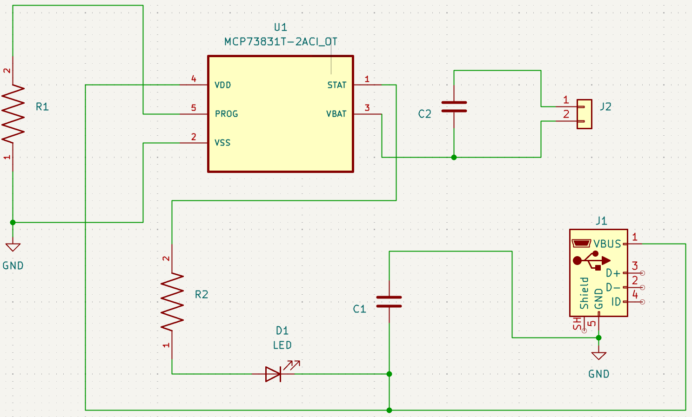 | Note(s):  - Typically 4.7µF to 10µF 0805 MLCC capacitors are placed close to VBUS and VBATT.  - R2 is typically a current-limiting resistor for the LED (0.4 kΩ), and R1 (PROG) sets the charging current (e.g., 2kΩ for 500mA, 10kΩ for 100mA).  - The USB shell is internally connected to the system ground.
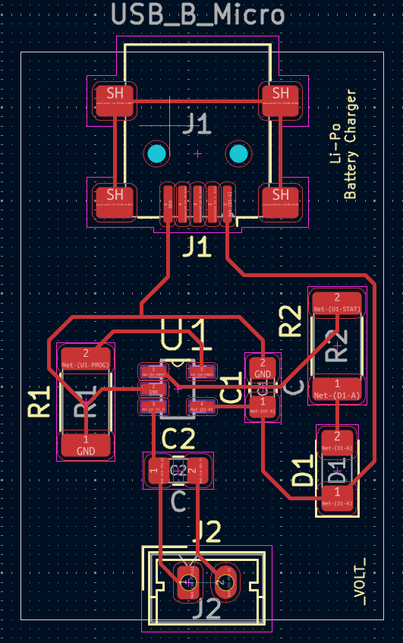 | - No track must make a 90 degree angle at any point.  - Strict adherence to distances between terminals.  - Each component of the PCB at its correct layer.  - Use of datasheets to check the dimensions of components.
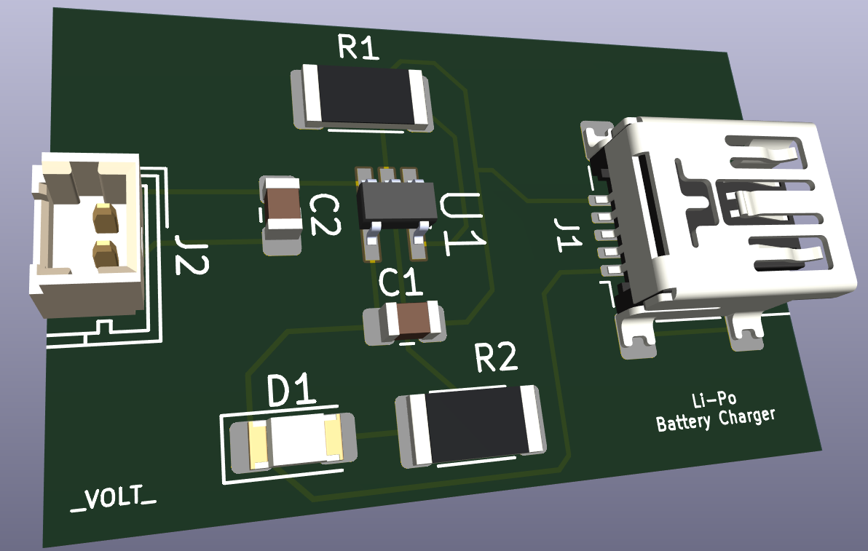 | - 3D packages for components are imported as STEP files into KiCad and used in the relevant project.

INTRODUCTION TO KICAD PROJECT

- LED, 3 Pole slide switch, Resistor, 2 pin terminal block

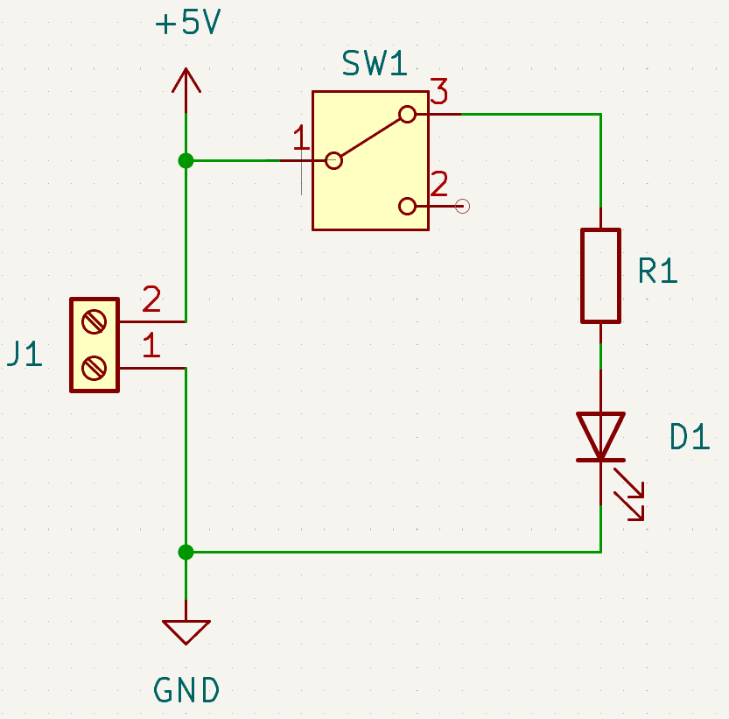
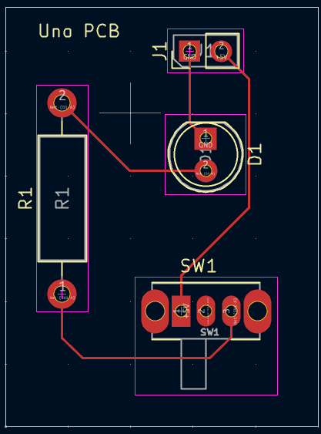 | - No track must make a 90 degree angle at any point  - Strict adherence to distances between terminals  - Each component of the PCB at its correct layer  - Use of data sheets to check dimensions of components
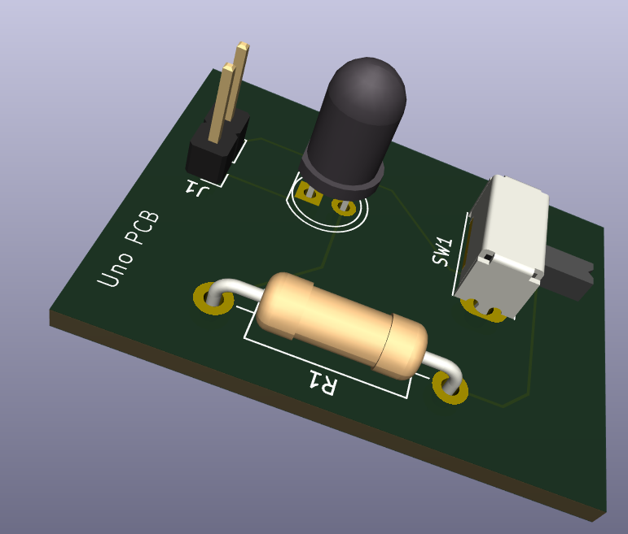

Organization/Team Name:

Dates: Duration of involvement.

Role: Your specific title (e.g., Team Member, President, Research Assistant).

Overview

A 1-paragraph summary of the project’s goal, the team’s achievements (like competition rankings), and the technical materials/tools used.

Individual Responsibilities

Use bullet points starting with strong action verbs (e.g., "Designed," "Manufactured," "Managed").

Quantifiable Results: Include specific tolerances, weights, or speeds (e.g., "machined to within $\pm 0.001in$").

Soft Skills: Mention communication, funding, or mentoring roles.

Visuals & Links

Media: Include photos of the final product, "action shots" of testing, and CAD/FEA diagrams.

Captions: Label your photos (e.g., "L to R: Me with the prototype...").

External Proof: Provide links to news articles, YouTube videos of tests, or technical papers.

Pro Tip: Use QR codes for links so they are accessible from a printed copy.

4. Technical Deep Dive (Optional)

Sample Write-up: If you have a particularly complex task, include a "Sample Write-up" or "Project Test Report".

Data Visualization: Include graphs (like acceleration vs. time) to show you can analyze and verify your models through testing.

5. Handling Sensitive/Proprietary Work

If you cannot show photos due to NDAs or commercial sensitivity, explicitly state this.

Workaround: Instead of photos of the actual hardware, use generic diagrams, flowcharts of your process, or scripts you wrote (e.g., MATLAB) to show the method without exposing the secret.

